Adaptation of “What Exactly is a Hero?” by T.A. Barron
Life is full of good and bad. We may be alone. We may have friends. Life is surprising! 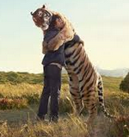
A hero in life will need many qualities. A hero is brave. A hero is wise. A hero never gives up.

What is a hero? A hero is not a celebrity. 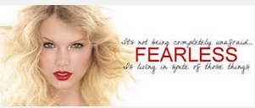A celebrity is famous for a short time. A hero is better than that. A hero is strong, brave, and wise. A hero will make a difference.
A celebrity gets attention for a short time. A celebrity is famous. A celebrity may or may not be a good person. A hero may be a celebrity. 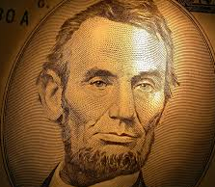 Not all celebrities will be heroes. 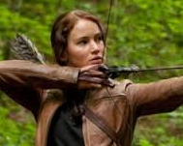
A hero does something that is important. It does not matter if someone else knows about the hero or not. A celebrity wants someone to see. 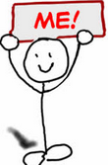
A hero is about what is inside someone. A hero is about what a person thinks, feels, and does.
Lao-tzu was a famous Chinese thinker. 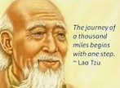He said that a long trip begins with one step. I
Our choices show who we are on the inside. Our choices show what is important to us. Our choices show other people who we are. 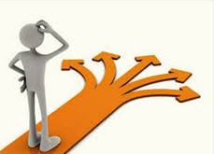
Each choice is like a step. What we choose will make our lives. What we choose will make us heroes or not.

